Pearl Ayem - 34404160

**ATSC 303 Lab 6 – Hygrometry**

Lab Questions:

1. Indicate the area(s) on the graph that represent each scenario.

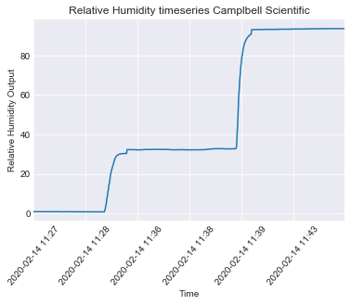

1. The formula used to find vapour pressure (e) was as follows:

Indicate the area(s) on the graph that represent each scenario.

1. The values generated are as follows:

|  |  |  |  |
| --- | --- | --- | --- |
|  | Average RH | Average Temp | Mixing ratio |
| dry | 6.111700 | 23.816444 | 1.123647 |
| ambient | 37.801958 | 23.285375 | 6.792036 |
| humid | 93.486667 | 23.571611 | 17.377711 |